**18-653 Project Tutorial**

1. Install mysql, please use brew to install myql. Then run the mysql.server restart to initialize the mysql. If you have installed the mysql with Mac, you can start the mysql server via System Preferences → MySQL → Start MySQL Server, which is showing as below:

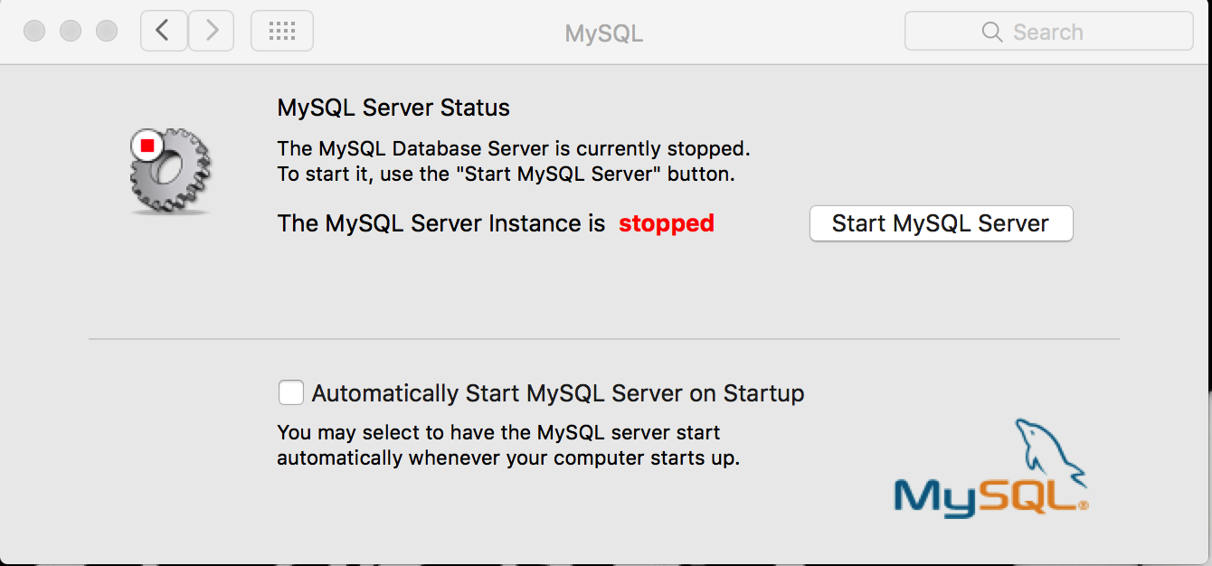

1. Connect to the mysql (make sure mysql has running on port 3306) and create schema called test_db with a username is “root” and password is void. No tables needed to be created because they will be created automatically by backend. Before you login into mysql, you can set global environment by PATH=”$PATH”:/usr/local/mysql/bin.
2. cd into [ApacheCMDA-](https://github.com/cmusv-sc/SOC-Fall-2015-Team13-Bowen-Zhang/tree/master/ApacheCMDA-Frontend)Backend, run ./activator "run 9034", then will see the following picture

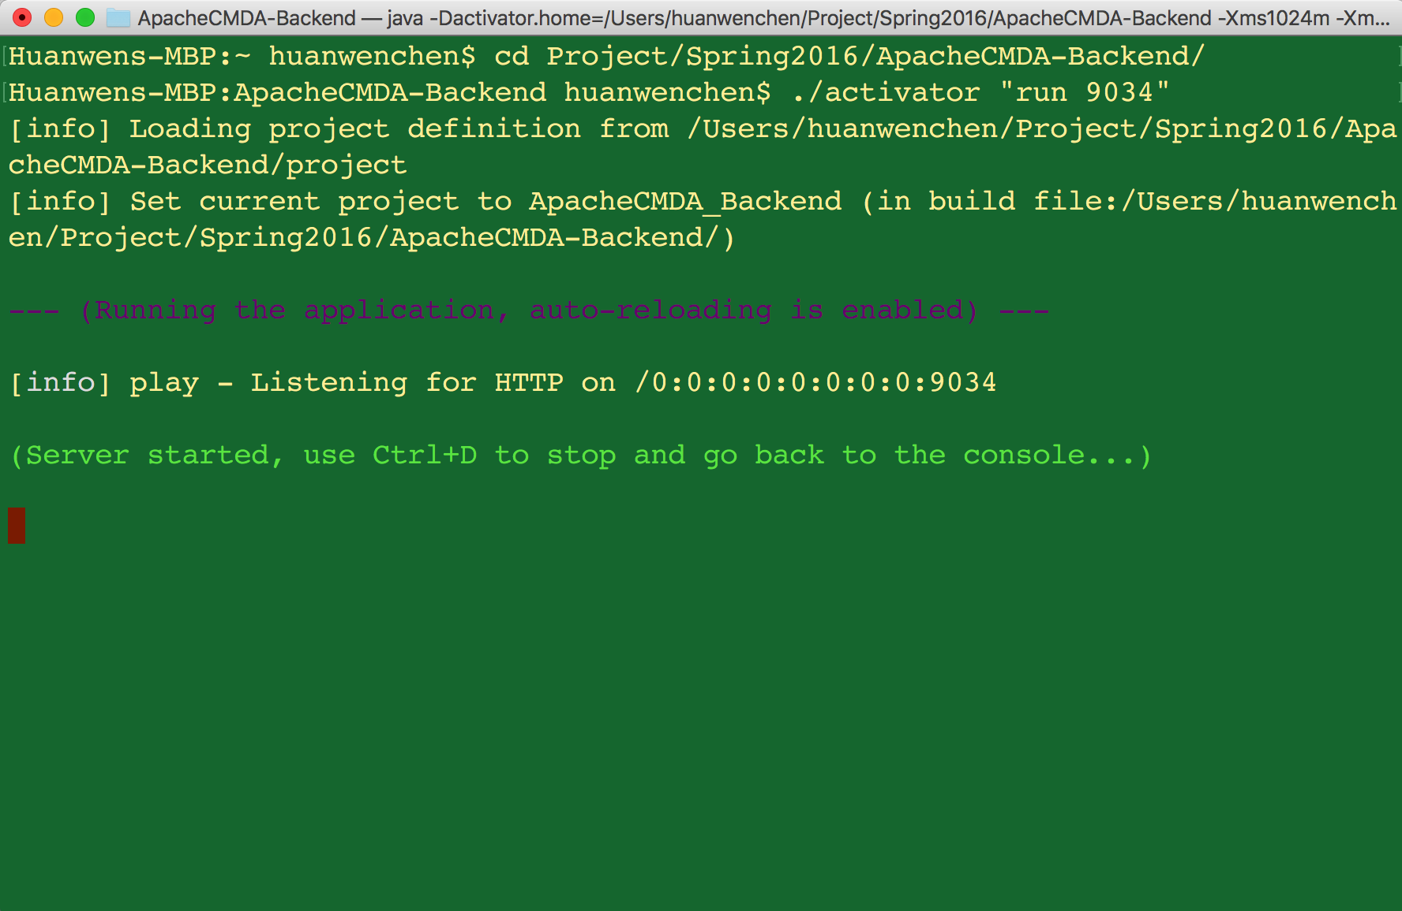

1. cd into [ApacheCMDA-](https://github.com/cmusv-sc/SOC-Fall-2015-Team13-Bowen-Zhang/tree/master/ApacheCMDA-Frontend)Frontend, and run the frontend with ./activator run, then will see the following picture

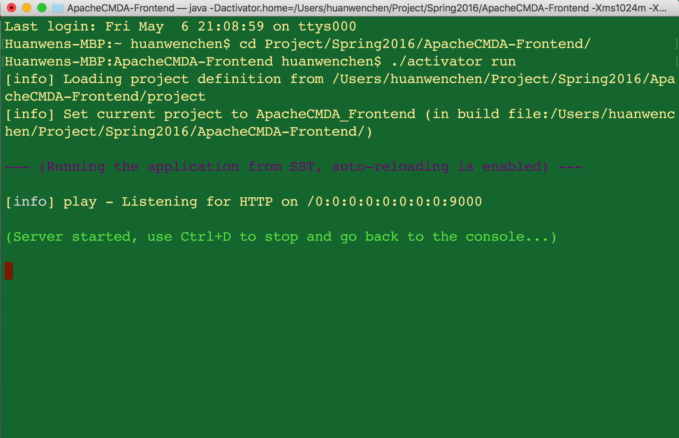

1. Open the browser and go to localhost:9000, you will see the main page showing as below:

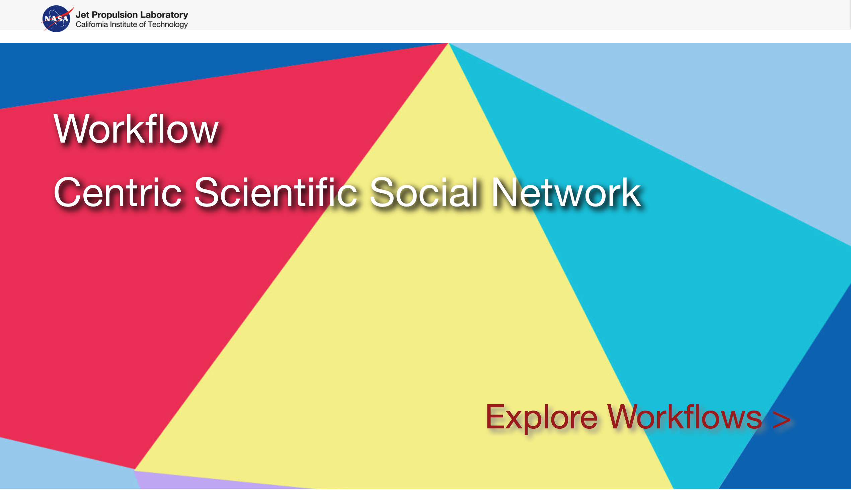

1. Then click Log in to register your account and begin the journey of the website.